Reflection on the Course Malaysian Society and Culture

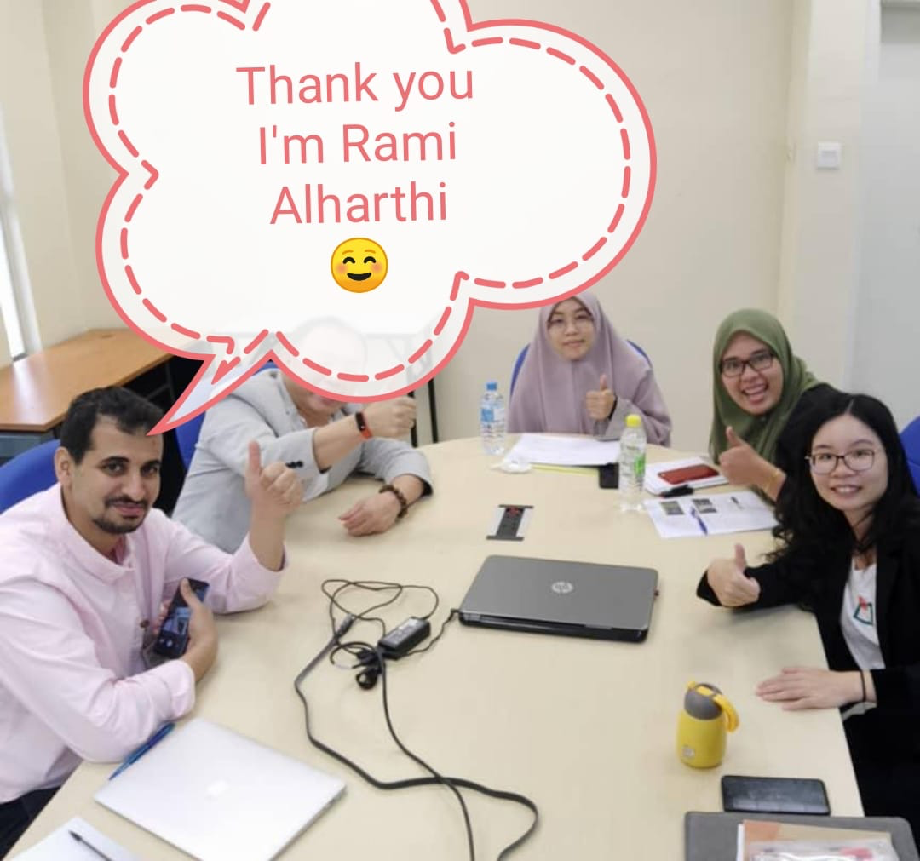

Aharthi Rami Hashem
Matrix number: PHA193017
Submitted to: Prof. Dr. Rozeyta Omar
10th of May 2020

Reflection
Feeling after Learning
I feel enlightened after learning about Malaysian culture and society. In this regard, I have been able to learn that Malaysia had a population of 28.4 million in 2016. I have also learned about the Malaysian that has led to cultural and religious integration in Malaysian society. I am now knowledgeable that the Malaysian maintained a unique identity that was different from the widespread Islamic world. I have also learned how the Malaysian established Malaysia as an economic stronghold. Besides, I have gained insight into the historical background of the Malaysian Chinese. Apart from Malaysian Chinese, I have acquired knowledge of the Malaysian Indians. Thus, I have learned how they migrated into Malaysia during the British colonization era and how they contributed to commerce within the nation. In this regard, I am opined that the Malaysian society is accommodative since the Malays did not have any challenges interacting with the foreigners.
Moreover, I have learned that Malaysia has indigenous populations such as the Bumiputera, and most Malays are Muslims. I have also learned that the Malaysian culture is oriented towards the kampong village. I have also learned that the Malays converted to Islam from Buddhism and Hinduism in the 14th century. I have gained insight into the foods that the Malays eat, including, sambal sotong, Ayam Masak Merah, roti jala, etc. From a religious standpoint, the Malays are prohibited from eating pork. Notably, most Malays eat using their hands as opposed to using cutlery. I have also learned some concepts in their costumes, including Baju Melayu, Batik, Baju Kurung, etc. Besides, I have learned that these costumes are differentiated based on gender. I have some information on the history of the Malays, including early settlers such as the Negrito-Bateq, Senoi, Dunia Melayu, etc. that contributed to the Malay identity. I have also learned how language has contributed to the Malay identity. Noteworthy, I have gained knowledge of how the Malaysian constitutional monarchy works alluding to the Yang di-Pertuan Agong and state leaders.
In addition, I feel more knowledgeable about certain issues associated with Malaysian culture and the community. I am amazed by some of the cultural norms when it comes to eating food. I learned from the course that only the fingers on the right-hand side could be used during eating. I also gained insight on table layout in the Malay culture. In this regard, the Malays are supposed to use minimum utensils on dinner tables. Malay people are expected to wash their hands using water on teapots known as kendi. Thus, I was able to learn despite the preference to use hands instead of traditional cutlery for eating; the Malays observe high standards of hygiene. As a result, the community has been able to mitigate the health risks associated with using bare hands to eat.
Furthermore, I found the wedding ceremony for the Malays interesting based on the procedure, mannerism, and the costume worn. I was able to learn that the first step before a marriage ceremony is a betrothal. The process entailed the wedding parties meeting to discuss a marriage proposal between the groom and the bride. The betrothal activity was done in the presence of both the grooms’ and brides’ parents. A successful proposal would be followed by a discussion of the amount of dowry that should be paid to the bride’s parents. Therefore, I was able to learn that their culture had some similar characteristics to most pre-wedding preparations of most cultures. I was able to learn that determination of the date of solemnization is carried out when dowry arrangements have been made. I was fascinated with the way the solemnization process was used to seal the marriage agreement between the wedding parties. The norm mentioned above differs significantly from church-based weddings where contracts are sealed on the altar on the day of the wedding. Like court marriages, I was able to determine that the Malays’ solemnization ceremony was required to have three witnesses. The mas kahwin presided over the ceremony the same as pastors in Christianity. I also learned that the Malays also ask God to bless the marriage. The Malay norms mentioned above have enlightened me that there is no significant variation between this culture and mine; the only difference is the terms used to describe the various procedures.
Expectations
At the beginning of the course, I had anticipated that the course would be boring learning about the Malaysian community and culture. I did not expect to be interested so much in the fine details that contribute to the Malaysian social organization. My aim was to meet all the course objectives and get a good grade in the end. However, at the end, I have gained so much interest in the Malays based on the intricate relationship between their culture and identity. Having read about and attending Malaysian festivals such as Hari Raya Puasa and Hari Raya Haji, I feel that I am unified with these populations since they have the most unique I have come across. I have developed a great interest in Malaysian meals, and I strive to incorporate them into my menu. In this regard, I expect to learn more about Malays even after the end of this course to gain extra insight into their various social, religious, and cultural aspects.
Also, I was expecting that the course would be like other courses on cultures that are always redundant. However, taking this cause has changed my perception of many things on multiculturalism and plurality. I have been able to learn how different cultures co-exist and the impacts that co-existence. In this regard, I have learned other cultures borrow from others to create distinct cultural values and norms that differentiate them from others. The course has offered me the opportunity of how the Malay Indians relate to the real Malays. As a result, I have not only obtained knowledge on the Malay culture but also that of the Malay Indians. The Malay Indians’ culture had a significant impact on that of the Malays. The Malay Indians carried out territory conquests on the Malaya area. The conquest of the Malaya region portrayed consolidation of power among the Indian rulers. In the pre-colonial period, the Tamil language was widely used in the region, especially during trade operations. In the end, the current Malays’ language was able to coin certain words from the Tamil vocabulary; more so, those that were associated with accountancy and book-keeping. I have put a target for myself to learn about the numerous ways the Tamil language contributed to the Malay language after the course.
Morals, Qualities, Skills, and Values Learned
From a moral standpoint, I have learned from the Malays that it is morally-appropriate to adhere to societal, religious, and cultural principles. For example, the way Malays treat guests shows that the community is moral-oriented. Besides, I have gained the value of obedience from the Malays with regards to certain norms such as how food is served as well as how men and women are supposed to dress. I have learned about the qualities of cooperation and kindness from the Malaysian integration of Malaysian Chinese and Malaysian India into society without discrimination. Lastly, I have gained the skill of speaking the Malaysian language from taking this course and interacting with my Malay colleagues. Therefore, I have learned a couple of words, and I think that this a great start to knowing the language completely.
Information about Malaysia
The course has helped me gain information about Malaysia since it incorporated course materials that helped me to gain insight into the geographical position of the country. The course has also helped me gain insight into the history of the Malays with regards to the indigenous populations and how their migration. The course has enabled me to learn about the Malaysian Chinese and the Malaysian Indians that now live in Malaysia, maintaining their cultural identities. Besides, I have learned how the cultural identity of the Malays revolves around their language. Notably, I have learned about the dishes and the costumes that are distinct to persons in Malaysia. I have learned about the festivals that are celebrated in Malaysia in a bid to reinforce their cultural values and norms. In this regard, the course has played an integral part in equipping with knowledge on the cultural, religious, and political organization of Malaysia based on the materials, assessments, and lessons.
Moreover, I have learned that Malaysia is located at the Southeast of Asia and is surrounded by the India Ocean. I have learned so much about the Eastern world using the context of Malaysia. I have learned that the country is proximal to Singapore to the South and Brunei to the East. I have also learned that countries such as Thailand, Vietnam, Cambodia, Myanmar, and Laos are to the North of Malaysia. I have also learned that the Gulf of Thailand is adjacent to the Northern part of Malaysia within the Andaman Sea. Notably, I have also learned that Malaysia consists of states and federal territories such as Kelantan, Pahang, Perak, Penang, Perak, etc. I have gained insight that Malaysia covers an area of approximately 329,758 square kilometers. I did also know that there is Peninsular Malaysia that is also part of mainland Malaysia. The peninsular covers an area of approximately 131, 598 square kilometers. I also got to learn about the Malaysian flag to know what it symbolized. I have always had an interest in national flags since they speak a lot about the identity of a nation. Thus, I learned that the flag composes Islamic elements and aspects derived from the various states within the federation. Therefore, I learned that the fourteen points and fourteen stripes depict that all the states have equal statuses. On the other hand, the color red on the flag depicts bravery, strength, and courage. I learned that the color white portrays integrity and honesty, while the color black represents harmony and unity.
Intellectual and Emotional Impact
The course has impacted positively on my intellectual capabilities as a foreigner in Malaysia. I have been able to gain a lot of insight into the culture and the language of people of Malaysia. Also, I have been able to learn about the composition of Malaysia with regards to the various tribal and ethnic groups. I have able to learn about how ethnic groups came to settle in Malaysia. Notably, I have been able to draw some interrelations among the Malays, Malaysian Chinese, and Malaysian Indians. From an emotional standpoint, the course has made have an affinity to the Malaysian culture. I have fallen in love with Malaysian dishes, attires, and festivals. I feel like part of this culture despite a foreigner in the country.
Notably, I learned that Malaysia is a federal constitutional elective monarch. Taking the course has enabled me to have a better understanding of how this kind of governance works. I have gained a lot of knowledge on the leadership of the country, including the federal head known as the Yang di-Pertuan Agong; the name refers to the King of Malaysia. I have learned that a King is often elected after every five years from the hereditary Sultans that come from the various Malay states. The King depends on the advisory from the elected government of the day. Besides, I have gained a comprehensive insight into the constitutional monarch of the country. The King has duties such as appointing and dismissing cabinet members. He or she is also the Commander of the Armed forces. I also learned that the rule has the authority to appoint judges and other key members within the justice system. Learning about the governmental infrastructure of Malaysia made me appreciate diverse leadership structures. The efficacy of this kind of leadership structure is reflected in the economic and government soundness of Malaysia.
Adaptation as a Foreign Student
The course has helped me adapt in Malaysia as a foreign student since I have been able to some Malaysian words that I can use to communicate with others. Even though I am not fluent in the Malaysian language, I decipher some words, and this had aided in my interactions significantly. Also, I have learned about the Malaysian dishes, and this has made me more familiar with foods in this country. Thus, I can order foods easily when I go to the market or restaurants without feeling like an odd one out. Most importantly, the course has enabled me to appreciate the Malaysian culture more based on the comprehensive coverage of the same. In this regard, I feel more comfortable staying in this country since its cultural, religious, and political values resonate with my ideologies. Conclusively, I do not feel left behind when it comes to interacting with my colleagues and other people during my day-to-day activities.

